**Name:** Ahmed Essam Ali Taha **Topic**: Artificial Intelligence

**Code:** 106

|  |
| --- |
|  |

**Application Brief**

**Artificial Intelligence** and **Machine Learning** are products of both science and myth. The idea that machines could think and perform tasks just as humans do is thousands of years old. The cognitive truths expressed in **AI** and **Machine Learning** systems are not new either.

|  |
| --- |
| **Links**  Github link: <https://github.com/ahmed2962/html-project-repository>  Github padges (puplished-website) <https://ahmed2962.github.io/html-project-repository/>  **Source Code**  <html>  <body  style="background-image:url('565.jpg')">  <h1 style="color:rgb(0, 217, 255);">Home</h1>      <ul>    <li><a href="Defination of AI.html"><H2 style="color:WHITE;">Defination of AI</h1></a></li>   <li><a href="The Goals of AI.html"><H2 style="color:WHITE;">The Goals of AI</h1></a></li>    <li><a href="Classification of AI.html"><H2 style="color:WHITE;">Classification of AI</h1></a></li>      <li><a href="Applications of AI.html"><H2 style="color:WHITE;">Applications of AI</h1></a></li>  </ul>  </body>  </html> |

**Screen Shots of WEB site**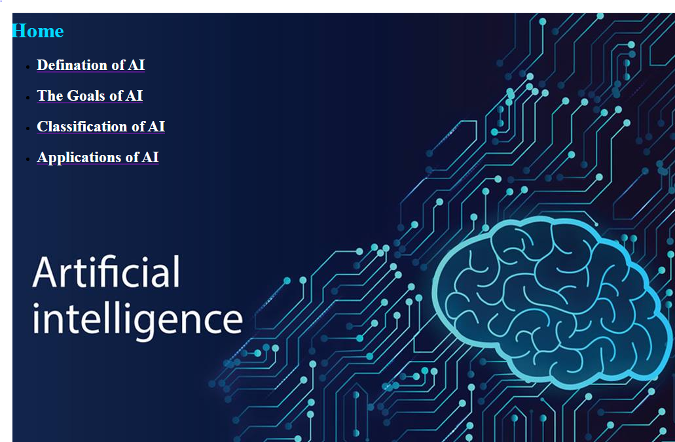

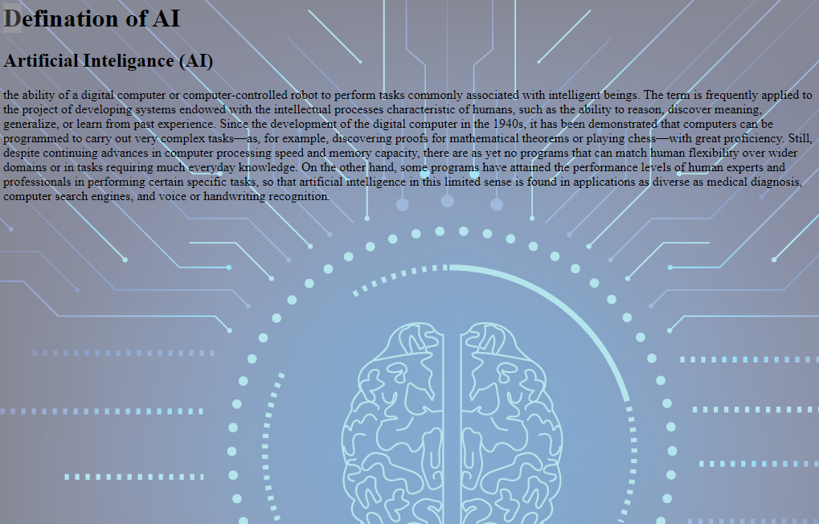

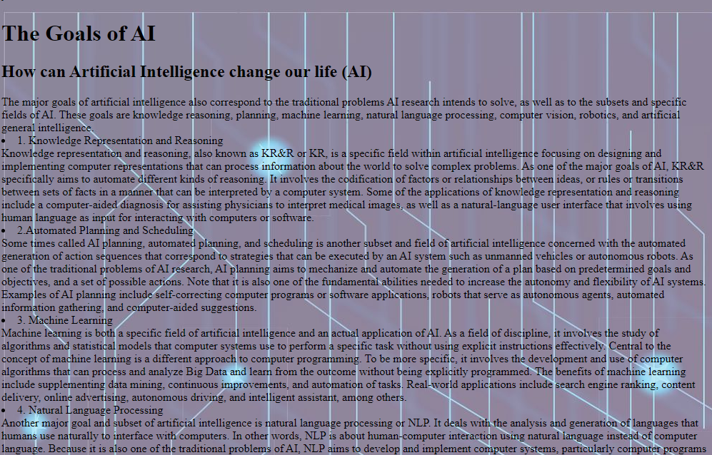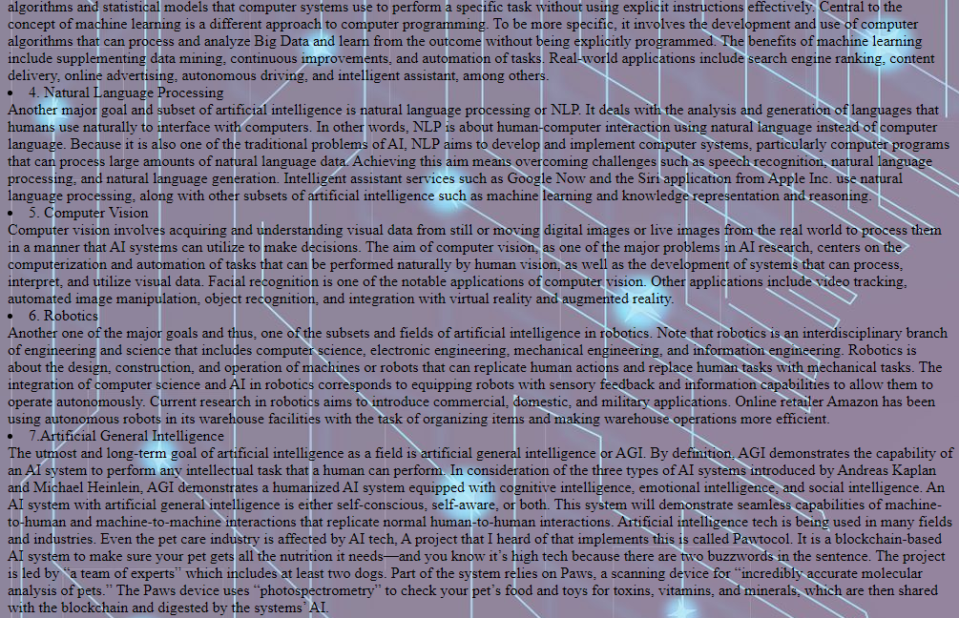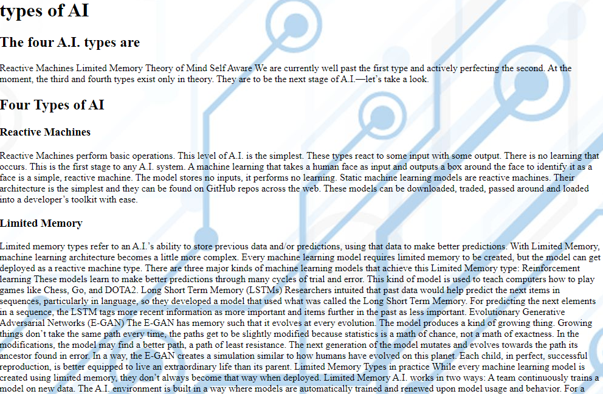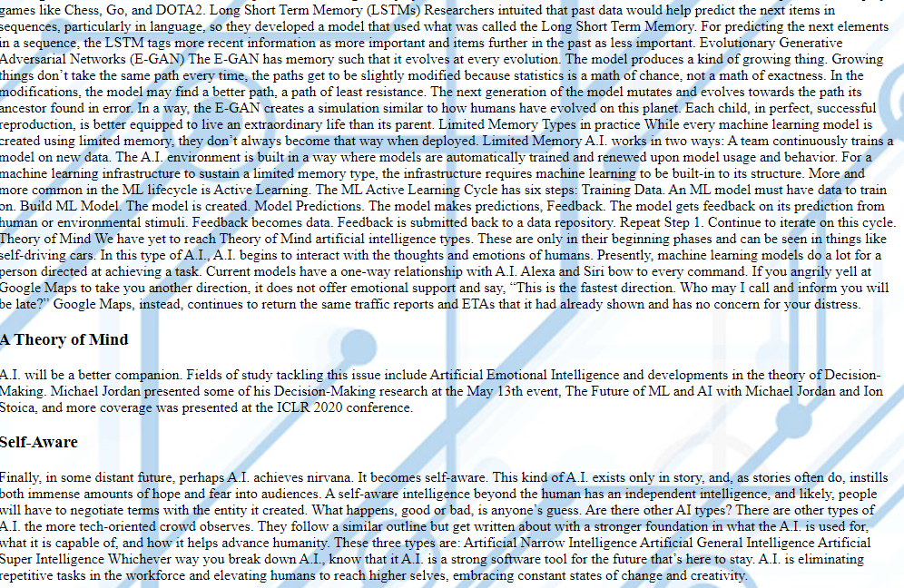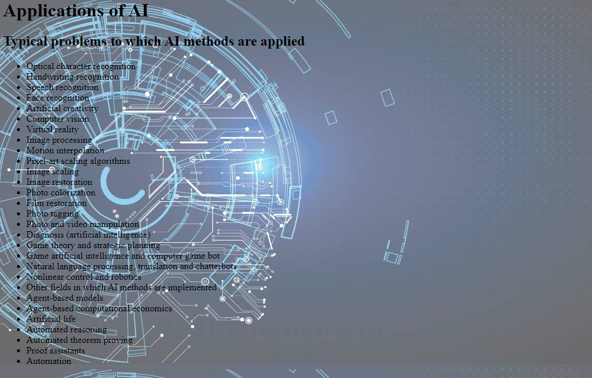

**Screen Shots of Code source**



